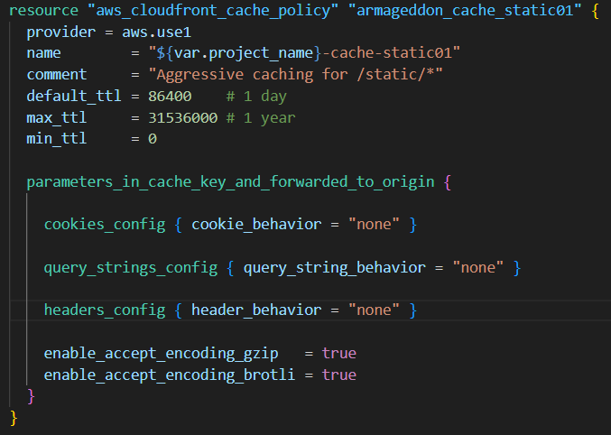
What it is: A Cache Policy tells CloudFront how to build the cache key (what makes two requests “the same object”) and how long to cache objects.
Key parts:
- provider = aws.use1
CloudFront is a global service but its control plane resources are typically managed in us-east-1, so you’re creating this policy via that provider alias.
- default_ttl = 86400 (1 day), max_ttl = 31536000 (1 year), min_ttl = 0
If your origin doesn’t specify caching headers, CloudFront will cache for 1 day by default, up to 1 year. min_ttl=0 means CloudFront is allowed to not cache if headers dictate.
- cookies_config { cookie_behavior = "none" }
Cookies are not part of the cache key and not forwarded to the origin. Good for static assets because cookies would explode cache variations.
- query_strings_config { query_string_behavior = "none" }
Query strings are ignored for cache key and not forwarded. Good if your static asset URLs don’t use query params for versioning.
Note: if you use app.js?v=123, ignoring query strings could serve the wrong version.
- headers_config { header_behavior = "none" }
No request headers are included in the cache key or forwarded. Again, reduces cache fragmentation.
- enable_accept_encoding_gzip = true, enable_accept_encoding_brotli = true
CloudFront will cache different compressed variants when needed (gzip/brotli) and deliver the best one to the viewer.
Bottom line: This makes /static/* cache very efficiently with very few cache-key variations.
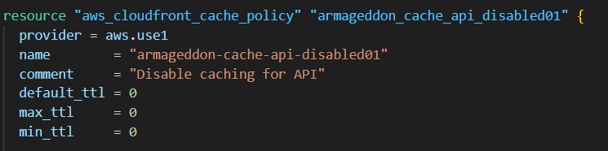
What it is: Another cache policy, but tuned so CloudFront effectively does not cache.
Key parts:
- default_ttl = 0, max_ttl = 0, min_ttl = 0
This tells CloudFront: “treat everything as immediately stale.” In practice, CloudFront will go to origin for each request (though CloudFront can still do conditional revalidation in some scenarios if other settings/headers come into play).
- Cookies/headers/query strings set to "none"
Meaning: none are included in the cache key and none are forwarded by this policy.
Important: forwarding is mostly controlled by the Origin Request Policy, which you define below.
Bottom line: Use this policy on /api/* behaviors so API responses aren’t cached.

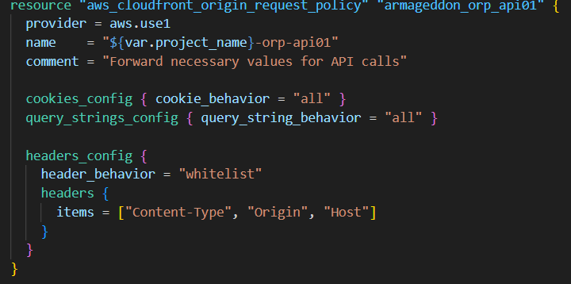
What it is: An Origin Request Policy (ORP) tells CloudFront what to forward to your origin (ALB/EC2/S3) on cache misses (or always, if caching disabled).
Key parts:
- cookies_config { cookie_behavior = "all" }
Forward all cookies to the origin. This is often required for authenticated/session APIs.
- query_strings_config { query_string_behavior = "all" }
Forward all query strings (e.g., pagination, filters).
- headers_config { header_behavior = "whitelist" ... } with:
  - "Content-Type": useful for POST/PUT and content negotiation.
  - "Origin": useful for CORS decisions at the origin.
  - "Host": sometimes needed if your origin logic depends on hostnames (or you’re doing host-based routing / multi-tenant logic).
Bottom line: Even though you disabled caching for API, you still want the origin to receive the stuff it needs to generate correct API responses
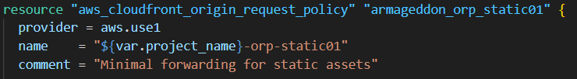
What it does: For static assets, you forward no cookies, no query strings, no headers.
Why: Static files should be identical for everyone; forwarding viewer-specific stuff just reduces cache hit ratio and increases origin load.

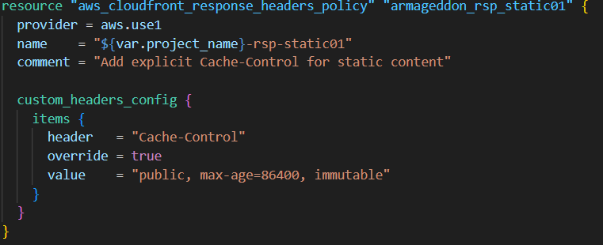
What it is: A Response Headers Policy lets CloudFront add/modify headers on the response back to the viewer.
Key parts:
- Adds a Cache-Control header:
  - public = can be cached by browsers/shared caches
  - max-age=86400 = browsers cache for 1 day
  - immutable = tells browsers “don’t revalidate; this won’t change” (best when filenames are versioned/hashes like app.abc123.js)
- override = true
CloudFront will replace any Cache-Control coming from the origin with this one.

